East West University

Course Title: Green Computing

Course Code: CSE407

Section no: 03

Mid Assignment

Group: 06

Topic Name: EWU IT Equipment Purchasing Process

Submitted to:

**Dr. Md. Hasanul Ferdaus**

Assistant Professor

Department of Computer Science & Engineering,

East West University

Date of Submission: 08/12/23

Submitted By:

| Name | ID |
| --- | --- |
| Ishrat Jahan Shimu | 2020-1-60-157 |
| Korobi Sarkar | 2020-1-60-161 |
| Md Siamul Islam Shayon | 2020-2-60-017 |
| Amit Ghosh | 2019-1-60-263 |

Table of Contents

1. Abstract
2. Introduction
3. As-Is Model and its brief explanation.
4. To-Be Model and its brief explanation.
5. Modification of the To-Be model
6. Validation
7. Conclusion

**EWU IT Equipment Purchasing Process**

**Abstract :** The aim of our Report is to explain the process of purchasing IT tools of East west University. To draw the process model we have used BPMN 2.0 model .There in As-is model we have explained every step of the ongoing process of how the varsity buys the IT tools and in TO-Be model we have modified the process by adding some tasks which will reduce e-waste.Eventually , we have validate the As-is and To-be model with the stakeholders.

**Introduction:**  Efficient procurement of IT equipment is crucial, for businesses in the realm of friendly technology. Embracing IT practices not only helps conserve the environment but also enhances operational efficiency. Green IT involves acquiring energy hardware, optimizing data centers to reduce carbon emissions and adopting Eco disposal methods. By prioritizing IT equipment businesses can minimize their energy consumption and responsibly manage electronic waste. Furthermore, investing in technology allows businesses to align with sustainability goals and demonstrate social responsibility. The role of IT equipment is instrumental, in driving eco initiatives enabling businesses to grow while positively contributing to a sustainable future.The “IT Equipment Purchase” is a Business process model which will explain in details how a stockholder purchase IT tools from a store.For this model we have use BPMN 2.0 model process. In our As-Is model we have explained every step of purchasing IT tools from a IT shop and in our To-Be model we wanted to figure out how we can reduce Environmental waste according to green IT.

**As-Is Model:**

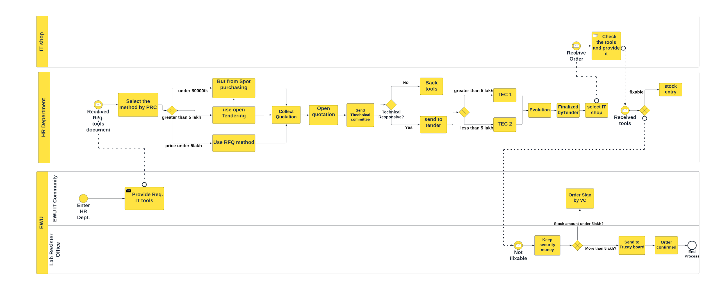

**Figure-1: EWU IT Equipment Purchasing Process (AS-Is)**

In this process we have seen that the main purchasing task is done by the HR department. When the lab manager finds out any issues with the IT tools they provide those tools to the HR department and then when they check the tools are really unusable they confirm the purchase of the components.

In this model HR department managers follow some Methods (e.g. If the price of the tools is under 5 lakh then use RFQ method ,if it is more than 5 lakh then use open tendering…)such as RFQ,Open Tendering.

[ Note: TEC=Tender Evaluation committee,PRC=Procurement Reassessment committee

**Procurement Methods:**

There are six procurement methods used by companies:

1. Open tendering

2.Restricted tendering

3.Request for proposal

4.Two-stage tendering

5. Request for quotations, and

6.Single-source procurement.

In our business process model we have used Open tendering and RFQ model so here is a brief discussion about them.

**Open tendering:**Open tendering encourages competitive bidding and requires local advertising, unbiased technical specifications, objective evaluation measures, openness to all qualified bidders, and the least cost provider. However, experts argue it's not suitable for large or complex acquisitions due to its focus on output processes.

**Request for quotations:** This procurement method is used for small-valued goods or services. Request for quotation is a simple, fast procurement method for small-valued goods or services. It involves selecting three suppliers or service providers, comparing their quotes, and choosing the best one based on requirement compliance.

**To-Be model:**

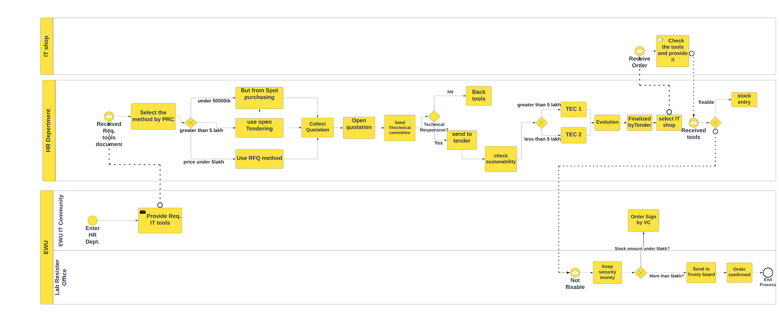

**Figure-2: EWU IT Equipment Purchasing Process (To-be)**

**Modification:**

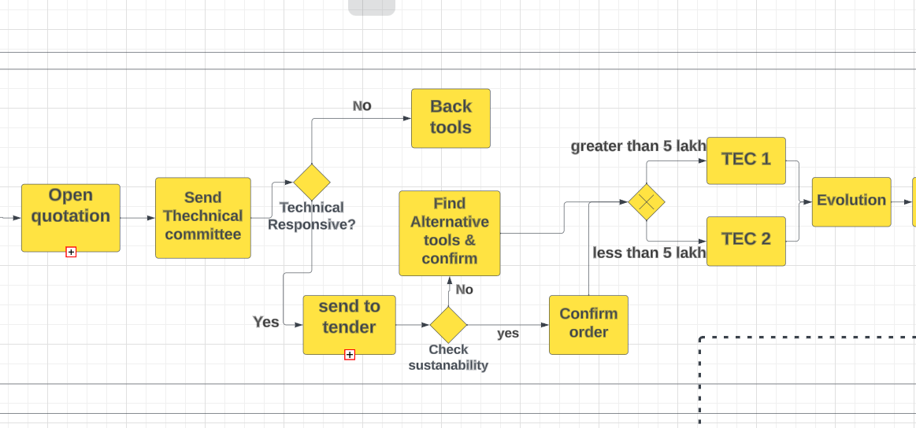

In our As-Is model we figure out some issues as HR department should more conscious before purchasing IT tools.Because of intense pollution already our environment are in serious threat, if we do not make awareness among us it will destroy us eventually.So we need use those products which are eco-friendly,reusable,recycling and inventory management ,volume reduction that cause less damage in our life and environment. In our **To-Be** model we have added an activity which is ‘check sustainability’ this task will check the components are really sustainable or not, if sustainable then confirm order if not then find alternative tools .This will ensure the sustainability, eco-friendly,reusable, recycling so that while we use the product it emits less pollution(e.g. Use LCd or LED monitor which will use less energy)and can makes the IT department greener while also encourage better energy consumption.

**Validation:**

**Syntactic Correctness:**Syntactic Correctness makes sure that the elements of the model are organized in a way that matches the abstract syntax of the model language.So,for correctness we have checked that our start event does not have any incoming edge and our end event does not have any outgoing edge.Besides ,all gateway and activity are connected by sequence flow and each sequence flow connect with at least 2 activity. So,there are no correctness errors in our model.

**Structural Soundness:**A process model is structurally sound when it has exactly one start event and one end event as our process model follows this so our model is structurally sound.

At last we can say after the interview we are able to know that there is validation in the As-is and To-be model with stakeholders. As there is no communication gap and stakeholders can buy IT tools without any hassle using this business model.

**Conclusion:** The business process model(As_Is) tells us the procedure of EWU purchasing IT components and in our TO_be model we modified it and make a better process model which will reduce e-waste.

**References :**

<https://open.hpi.de/courses/bpm2016/items/1bkgBPhojvWHl9O2RQcFvI>

<https://blog.udemy.com/procurement-methods/#:~:text=The%20six%20types%20of%20procurement,quotations%20and%20single-source%20procurement>